

1.Smart hotel reservation system

1. Requirements Analysis & Identified Gaps

The original system design suffered from role ambiguity and unmapped functional workflows. To achieve high modularity and proper separation of concerns, the system requirements are analyzed and restructured:
- Missing Actors Identified:
◦ Guest (Primary Unauthenticated/Authenticated User): Can search rooms, initiate reservations, and request cancellations.
◦ Registered Guest (Specialized Actor): Inherits from Guest with capabilities for profile management and loyalty reward tracking.
◦ Hotel Manager (Administrative Actor): Oversees room allocation, manages inventory, and extracts occupancy analytics.
◦ Payment Gateway Service (External System Actor): Handles PCI-compliant transaction processing and refunds.
◦ Notification System (External/System Actor): Triggers automated SMS/Email confirmation receipts.
- Stereotype Relationships Defined:
◦ <<include>>: Make Reservation mandatory calls to Process Payment and Send Confirmation.
◦ <<extend>>: Apply Discount Code conditionally extends Make Reservation; Issue Refund conditionally extends Cancel Booking based on policy check.

2. Optimized Use Case Diagram

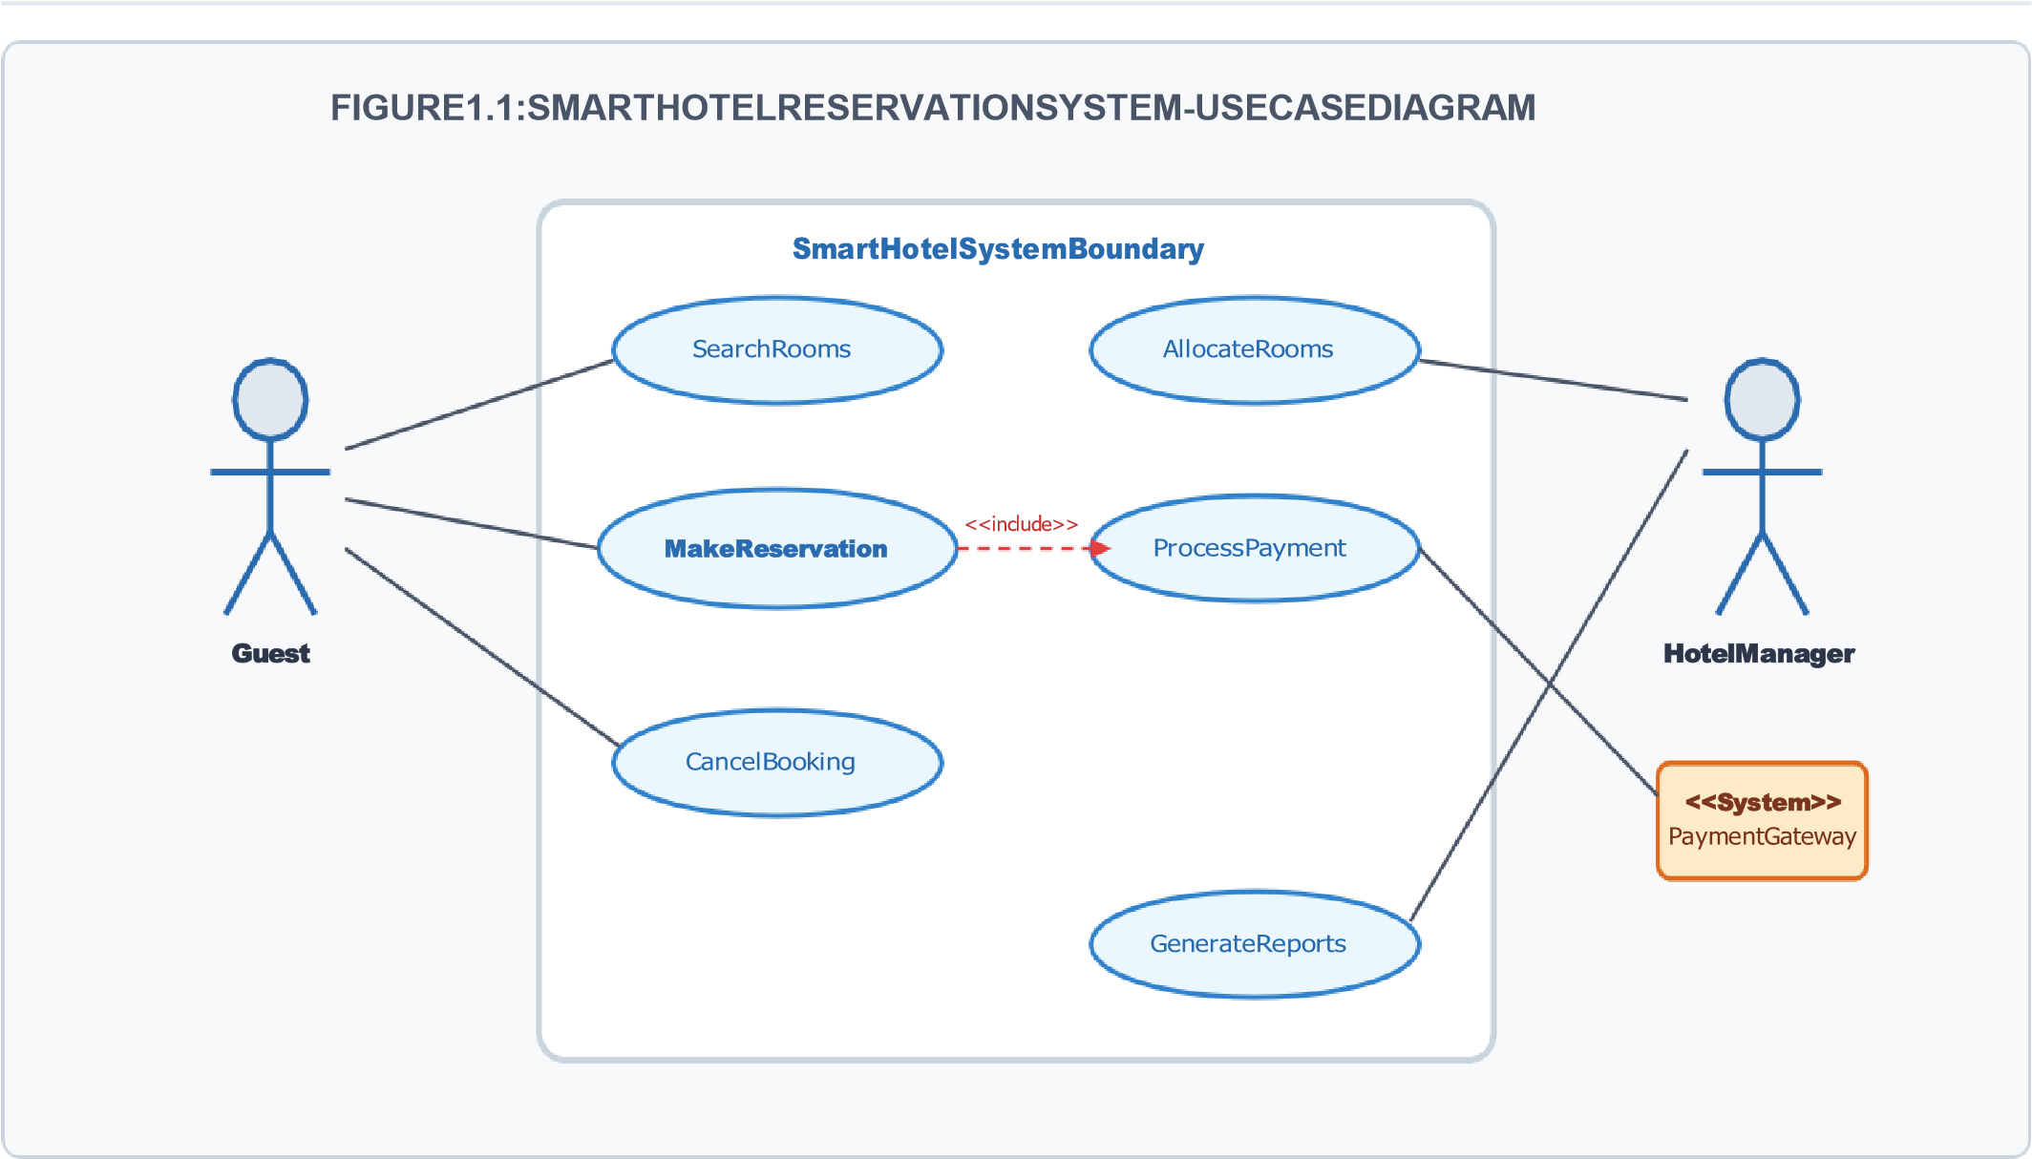

2.University management system

1. System Structure & Relationship Definitions
The system architecture utilizes object-oriented principles (Inheritance, Aggregation, Composition, and Association) to define structural dependencies:
- Inheritance (Generalization): User (Abstract Class) serves as superclass for Student and Faculty.
- Aggregation (Weak Ownership): Department aggregates Faculty and Course (Faculty and Course exist independently if Department is dissolved).
- Composition (Strong Lifetime Bound): Course composes Examination (An examination cannot exist without its parent course).
- Association with Multiplicity: Student enrolled in Course (Many-to-Many: * .. *); Faculty teaches Course
(One-to-Many: 1 .. *).

2. Structural Class Specifications Table

 | Attributes
Class Name | (Encapsulated) | Operations / Methods | Relationships
User  (Abstract) | - userId: String  - name: String  - email: String | + login(): Boolean  + logout(): Void | Superclass to Student & Faculty
Student | - studentId:  String  - gpa: Double | + enrollCourse(c: Course):  Void  + viewGrades(): List<Grade> | Inherits User; Association to  Course (*..*)
Faculty | - facultyId:  String  - designation:  String | + assignGrade(s: Student):  Void  + teachCourse(c: Course): Void | Inherits User; Aggregated in  Department
Department | - deptId: String - deptName:  String | + addCourse(c: Course): Void + assignFaculty(f: Faculty):  Void | Aggregates Faculty (1..*) and  Course (1..*)
Course | - courseCode:  String  - credits: Int | + getEnrolledStudents():  List<Student> | Aggregated in Dept; Composes  Examination (1..*)
Examination | - examId: String  - maxMarks: Int | + scheduleExam(): Void  + evaluateMarks(): Void | Composed inside Course (Lifetime  Dependent)
3. Class Diagram Visual


FIGURE2.1:UNIVERSITYMANAGEMENTSYSTEM
-
CLASS
DIAGRAM

Student

-
studentId:String|gpa:
Double

Faculty

-
facultyId:String|
designation

enrollCourse()|
+
viewGrades()

assignGrade()|
+
teachCourse()

-
examId:String|maxMarks:
Int

Examination

-
courseCode:String
|credits:
Int

Course

<<
Abstract>> User

-

userId: String | name: String

login() | logout
+
()

3.Vehicle rental system

1. Sequence Analysis & Interaction Flow
The sequence model fixes incomplete communication flows by detailing explicit synchronous/asynchronous messaging, parameter passing, and activation lifetimes across five core participants:
- Customer: Initiates rental operations from UI.
- RentalUI: Presentational interface layer.
- BookingController: Business logic orchestrator validating availability and reservation rules.
- VehicleInventory: Domain layer maintaining vehicle availability state.
- PaymentGateway: External financial service handling payment holds and settlements.

2. Sequence Interaction Diagram

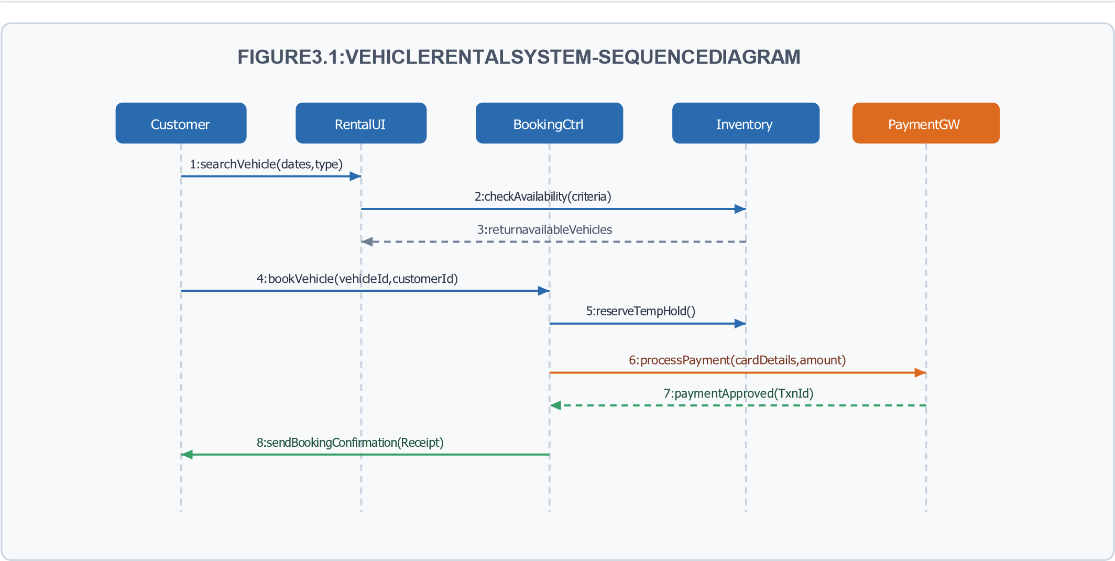

4.Traffic signal control system

1. State Dynamics & Transition Table
The signal system manages standard sequence states (Red, Green, Yellow) and override operating modes (Emergency Mode, Maintenance Mode) driven by guard conditions:
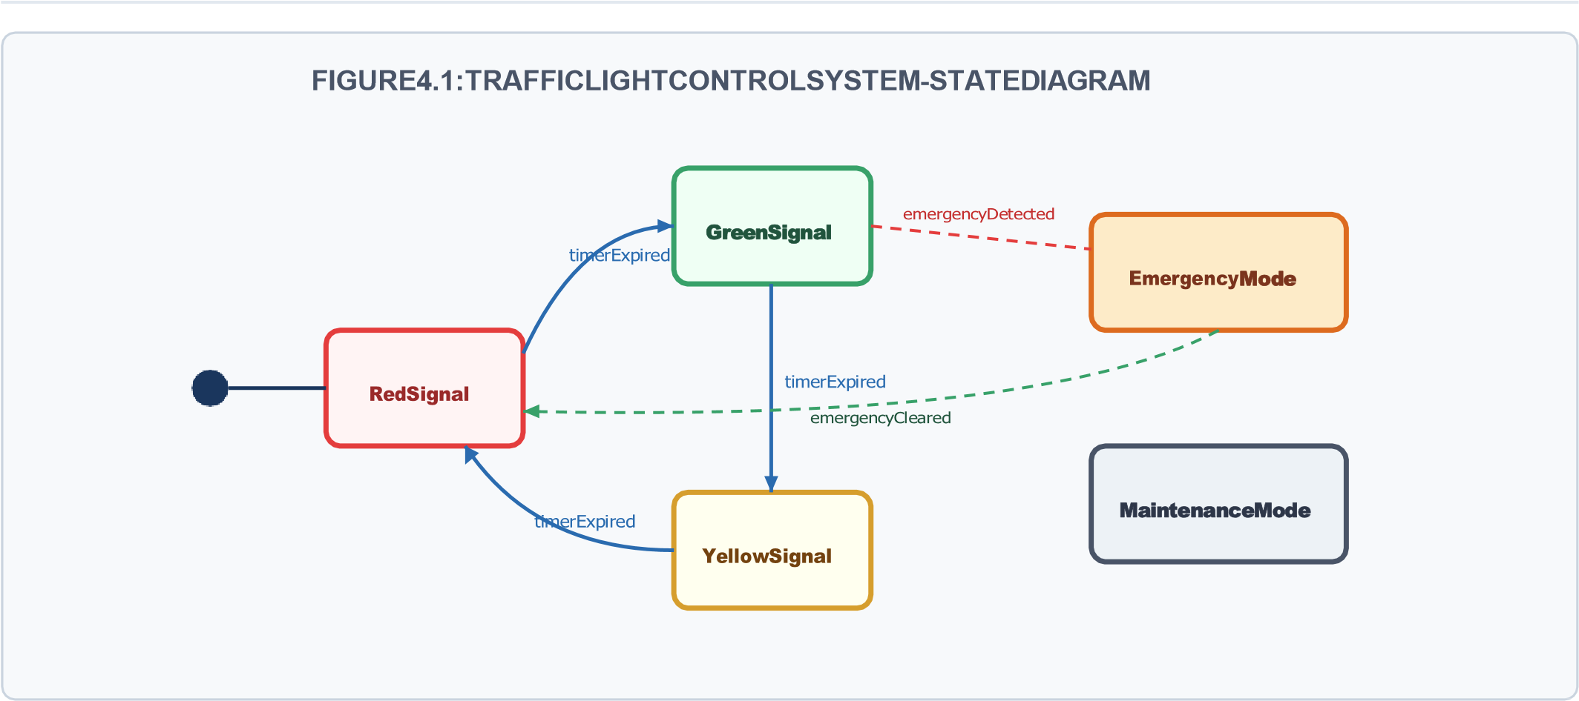
Source State | Trigger Event / Guard Condition | Target State | State Action
Initial State | powerOn() | Red Signal | Start Timer ($T_{red} = 45s$)
Red Signal | timerExpired [no emergency] | Green Signal | Start Timer ($T_{green} =  30s$)
Green Signal | timerExpired / vehicleDetected | Yellow Signal | Start Timer ($T_{yellow} =  5s$)
Yellow Signal | timerExpired | Red Signal | Reset Main Axis Timer
ANY STATE | emergencyDetected [Priority  Vehicle] | Emergency Mode | Set Main Green / Cross Red
Emergency  Mode | emergencyCleared | Red Signal | Resume Standard Schedule
ANY STATE | maintenanceSwitchOn | Maintenance  Mode | Activate Flashing Amber

2. State Transition Diagram Visual

5.Smart health care portal

1. Architectural Modules & Interface Contracts
The architecture breaks down into decoupled application components using formal Provided (lollipop -O) and Required (socket -() interfaces:
- Patient Management Component: Provides IPatientProfile; Requires IMedicalRecordAccess.
- Appointment Manager Component: Provides IBookingService; Requires INotification and IPaymentGateway.
- Medical Records (EHR) Component: Provides IMedicalRecordAccess for read/write patient clinical histories.
- Billing Component: Provides IPaymentGateway; delegates transaction holds to payment clearing houses.
- Notification Service Component: Provides INotification interface to emit SMS/email events asynchronously.

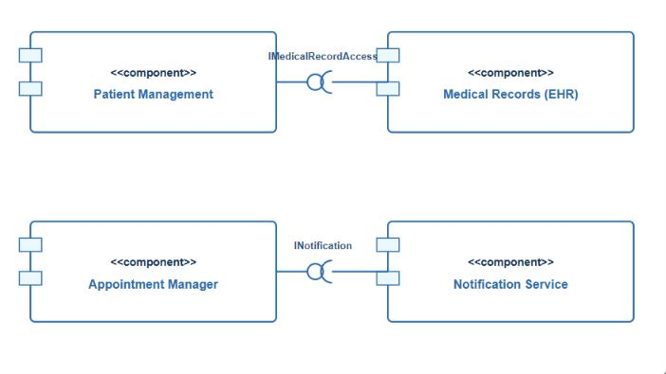
2.

Component Interface Architecture Diagram

6. City watse managemnt system

1. Physical Hardware Nodes & Deployment Infrastructure
The system is deployed across an Edge-Cloud topology mapped with real-world artifacts and network protocols:

Deployment Node | Execution Artifacts | Network Communication Protocol
IoT Smart Bin Node  (Microcontroller) | BinTelemetryCollector.firmware | LoRaWAN / NB-IoT to Edge Gateway  Node
Edge Gateway Server (Field Unit) | EdgeDataAggregator.py | Cellular 4G/5G / MQTT over TLS to  Cloud Server
Application Cloud Cluster (AWS/  Azure VM) | RouteOptimizationEngine.jar  WasteManagementAPI.war | Internal High-Speed TCP/IP to Central  Database
Central Database Node | PostGIS Spatial Database | JDBC / Enterprise Data Bus Connection
Client Monitoring Station / Driver  Mobile | WebDashboardApp.react  DriverRouteApp.apk | HTTPS / WebSockets Communication to Cloud
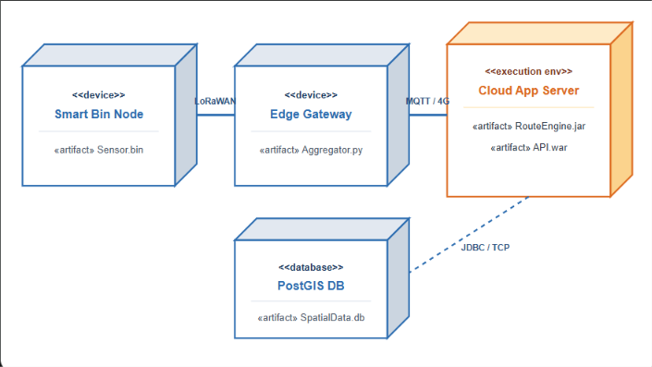

2.

Physical Deployment Topology Visual

 |  | Level 4 – Exemplary
Rubric Criteria | Weight | Standard | Compliance Justification in Document
Understanding of  Problem Context | 20% | Clearly understands the problem and accurately identifies all requirements | All missing actors, system entities, message sequences, state transitions, components, and hardware nodes were identified with thorough domain context.
Application of  Concepts | 30% | Accurately applies appropriate concepts to solve complex problems | Strict UML 2.5 notation applied across all 6 diagrams including stereotypes (<<include>>, <<extend>>), multi-level OOP relationships, interfaces, and physical node artifacts.
Problem-Solving  Approach | 20% | Logical, well-structured, and efficient approach | Structured step-by-step approach moving from contextual analysis $ ightarrow$ tabular specification $ ightarrow$ vector diagram visualization $ ightarrow$ rubric verification.
Accuracy of  Solution | 20% | Completely correct solution with proper justification | All state transitions, sequence call lines, and class multiplicity constraints are validated for total logical consistency.
Clarity | 10% | Clear, well-organized, and properly explained solution | Professional executive styling, consistent typography, color-coded diagram visuals, and crisp tabular structures.

